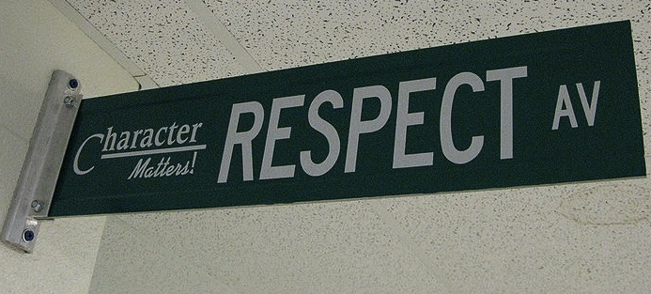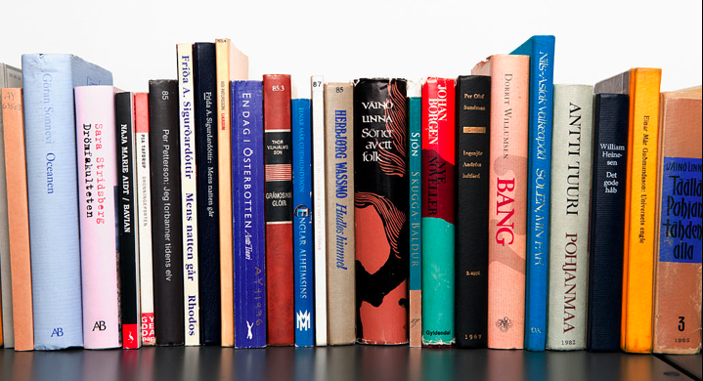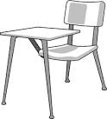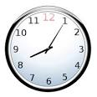

**Supplies**

* **Pencils**
* **2 Different colored highlighters**
* **2 Composition Notebook**
* **2 Tissue Boxes**
* **2 Pocket Folder**
* **1 Three Ring Binder**
* **Red and Blue/Black Pens**
* **Hand Sanitizer**
* **Lined Paper**

**Website:** [**https://mrshedgesclassroom.weebly.com/**](https://mrshedgesclassroom.weebly.com/)

**Email:** [**41.khedges@nhaschools.com**](mailto:41.khedges@nhaschools.com)

**Warrendale Phone Number: (313) 240-4200 Ext 217**

## Contact Information

Dear Parents/Guardians,

As your children begin sixth grade, I am writing to welcome your families to my class and introduce myself. I will be your scholars teacher this year. My name is Mrs. Hedges, and this will be my fourth-year teaching. Previously I was a middle school English teacher where I helped many students achieve awards at various levels such as Academic Olympics and scholarships for writing when they moved on to high school.

My goal this year is to help your scholar reach their potential and prepare them for success with their future. I have an open-door policy and you are more than welcome to contact me with any of your concerns, joys, or uncertainties.

# Welcome

#### Be kind & be respectful.

### Class Expectations

#### Follow directions the first time they are given.

#### Raise your hand and wait to be called on before speaking.

All school rules also apply.

#### Ask permission to leave your seat.

#### Be on time & be prepared.

welcome to 6th grade